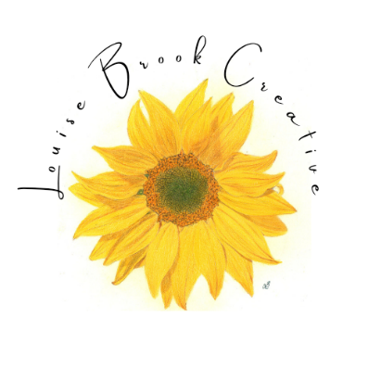
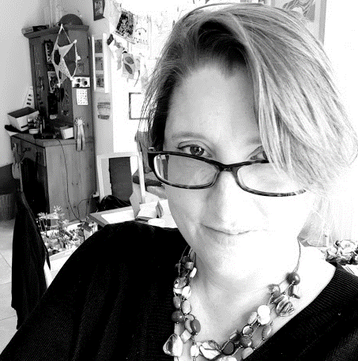
________________________________________________________________________________

Louise Brook Creative
Fine Art Artist

_________________________________________________________________________________

Artist Bio
Northamptonshire based Fine Art Artist, Louise Brook, has experience working across multiple styles and mediums. In her abstract work, Louise uses layers of acrylic paint and mixed media to create rich texture and visual interest, whilst inviting the viewer on a journey to explore a contemporary narrative or more complex overarching theme. Since moving out of London to focus solely on her artistic career her work has continued to evolve and bold, exciting abstract works have become her predominant focus.
Louise describes her inspiration as a broad, natural curiosity to explore complex topics. Ideas are drawn from an exciting variety of sources ranging from current affairs to academic research, using storytelling and discovery to create an accessible narrative. Her intention is to inform and intrigue, sparking interest, curiosity, and conversation. Her most recent achievements are selection for two London Exhibitions (at Espacio Gallery and The Holy Art Gallery), selection for the 8th Annual Colorful Abstractions Exhibition, hosted by Fusion Art and a feature in the February edition of Artist Closeup Magazine.

Artist Statement
The themes I explore through my art are wide-ranging, reflecting a thirst for knowledge and a natural curiosity that has been with me my whole life. I am fascinated by complex topics, by progress and by stark juxtapositions. Recent themes have included the cost-of-living crisis, the conflict between urban and rural living and the startling way in which human intelligence has evolved. Creating for me is a process of discovery and storytelling; the joy of a finished piece is in knowing that it can be enjoyed on many levels. Storytelling, discovery, and the element of surprise bring me joy and motivate me to create. My creativity is born of curiosity and the intention of my work, like the composition, is multifaceted. I aim to create pieces which are striking from a distance and demand closer inspection. What may seem simple on the surface reveals surprising, intricate details, gorgeous texture and a compelling narrative woven through the layers of the piece. The purpose is to surprise and delight, to challenge and question and to leave the viewer informed yet intrigued sparking interest, curiosity, and conversation.

I work predominantly with acrylics and mixed media, which allows me to create depth and interest through rich layers and textural detail. I deliberately start each collection of works without a set theme in mind, building the surface, adding layers and developing texture. Through this process a subject will emerge – a topic that I am drawn to, current affairs, or simply an idea that keeps returning to my thoughts; from this point onwards, the artistic process progresses with this in mind. The collage materials I use are a vital part of my work; I carefully research and select collage pieces to illustrate my chosen theme. Working iteratively, much will get covered up during the creative process, more will be added in later layers. This approach of addition and subtraction, a back-and-forth journey through the painting, is something that really excites me; I don’t fear change within the artistic process, it often surprises me and gives the viewer tantalising glimpses of the narrative and artistic journey behind the piece.
My portfolio also includes highly realistic coloured pencil and watercolour work, reflecting my artistic journey to date (I started my artistic career as a as a pet portrait artist) and demonstrating my competence in a range of styles and mediums. Some of these works are still available to purchase. While this is not my current artistic direction, if your interest is realism, wildlife or even pet portraits then I am always happy to consider new works on a commission only basis.

Artist CV
Contact Details:
Name: Louise Brook
Website: www.louisebrookcreative.com
Telephone: 07973432423
Email: louisebrookcreative@gmail.com
Address: 3 Yew Tree Close, Middleton Cheney, Banbury, OX 17 2SU, United Kingdom
Job Title: Fine Art Artist
Social Media: https://www.instagram.com/louisebrookcreative
https://www.facebook.com/louisebrookcreative/

Education:
Largely self-taught, Louise has invested in some ad-hoc training helping her to explore different approaches and mediums, these include:
- Soraya French Workshop, Chacombe, July 2021
- Watercolour Projects, Rachel Cronin, The Mill Banbury (Autumn 2021, Spring 2022)
- Oil & Acrylic Classes, Nigel Fletcher, Sibford (Autumn 2021 to present, occasional workshops)
- Collage Kickstart, Catherine Rains (online, July 2022)
- Abstract stARTs course with Judy Woods (online, ongoing)
Exhibitions:
*UPCOMING*
The Holy Art Gallery, London
The Art Of Existence Exhibition
10th – 19th February 2023

Fusion Art, International Juried Online Exhibition
8th Annual Colorful Abstractions Exhibition
7th January – 7th March 2023
8th Annual Colorful Abstractions Art Exhibition – January 2023 - Fusion Art (fusionartps.com)

Espacio Gallery, London
Terra Exhibition
19th to 23rd October 2022

Church Lane Gallery, Banbury
Resident Artist
May 2021 to present

Woodbine Art, Middleton Cheney
Resident Artist
August 2021 to present

The Mill Arts Centre, Banbury
Oxfordshire Artweeks 2021
May to September 2021

Other PR:
Artists Closeup Magazine
Half page feature, February 2023

Career History:
Louise has had a steady stream of pet portrait commissions and has an established social media presence, ecommerce website and Etsy platform. She is both a Director and Finance Officer of Church Lane Gallery, helping to oversee the artistic and strategic direction of this vibrant artists’ cooperative. She is a member of the Visual Artists Association (VAA) and the Society of All Artists (SAA). Still relatively early on in her artistic career she is now looking to build on her early successes and is actively seeking more widespread gallery and exhibition experience. This has quickly started to come to fruition with two London exhibitions and selection for an International Online Juried exhibition.

